FPGA Keyboard Piano

**Project Description**

Our goal is to design and implement VHDL code that will simulate a piano using the DE2-115 board and a computer keyboard. The code will take input information from a computer keyboard and output a signal to a speaker, which will then play a specific tone that corresponds to the key pressed. At the most basic level, our objective is to create a program that can play tones through a speaker when a key is pressed on a keyboard. Once this is achieved, more features can be added. Some features brainstormed include the following: additional keys or switches to act as “pedals” of the piano to change the properties of the tones played, a way to switch the octave being represented by the keyboard, a graphic to show the “piano’s” keypresses, and even some songs built in.

To build this piano we will need to learn how to wire a speaker and a keyboard to the DE2. Getting these components to function properly when connected to one another may be a challenge. As of right now, it is unknown whether the components will be easily connected. The signals sent from the keyboard to the DE2 and from the DE2 to the speaker may need some translating in order to be properly comprehended. Once communication has been established between the keyboard (input) and the speaker (output), the next step will be to design a program that will send the speaker the correct signal when the corresponding key is pressed. This program at the most basic level will be heavily reliant on an if-then architecture. In order to implement this architecture in VHDL, the architecture will have to be recreated using logic gates.

This project is expected to take some hard work and dedication, but will also return a satisfying end result. The code needed to make this happen will need to be thoroughly tested and documented to ensure functionality in the end. Considering our current novice-status as VHDL users, it will require some learning and experience to be able to complete this project. Despite this, the keyboard piano is a feasible goal that can be achieved with some dedication.

**Resources**

Anticipated resources and components:

* Keyboard — user input
* Speaker — output
* DE2-115 board — computing machine
* Screen/monitor — display for graphics

**Quartus**

Nick — Quartus II 14.0 on Windows 10

Owen — Mac OS, Quartus not available

*Note: Could not get Quartus using WineHQ, for the program is too large*

**Project Tasks**

* The main task for this project will be to assign certain tones to specific keys on the computers keyboard. The tones will have to be placed on the keyboard in such a way to simulate similar positioning to how the notes on an actual piano are laid out.
  + The first feature we will add will use the switches on the FPGA board itself to change the octave at which the notes are playing. Depending on which switch is on and which are off, the notes being played may be higher or lower.
  + The next feature will include a piano graphic that comes up on the computer’s monitor. This graphic will show the layout of the piano, and which keys on the keyboard are assigned to which key on the piano. An example of such graphic can be seen in *Figure 1*.

*Figure 1*

* + The third feature we will add is an addition to the previous graphic. It will indicate which key on the keyboard is being pressed in real time. The graphic seen in *Figure 2* shows would be what it would look like if the user was holding down the ‘d’ key on the keyboard.

*Figure 2*

* + The fourth feature should use another switch on the FPGA board that, when switched on, will sustain the sound and act as one of the pedals on a real piano.
  + The final feature should play a simple song for the user when a certain button on the FPGA board is pushed. The graphic may also show which notes are being played in the song in real time as well.

*\*Note: All features after the base project will only be added time permitting, and will be given precedence in the order they are presented above.\**

**Project Schedule**

The chosen dates do allow for a lot of time to complete each task. The proposal, revised proposal, and final report are the only set due dates for this project. The base project and all of the other features are given approximate start dates, but are just set to be due by the end of the project. This is because most features will be a work in progress that can constantly be improved.

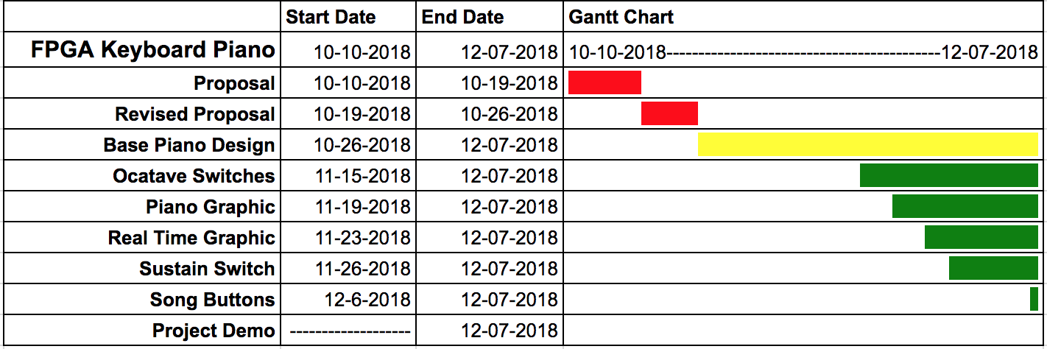

**Expected Challenges**

The first challenge we will most likely face in this project will be getting the speaker connected to the FPGA board. Figuring out where to connect the speaker, what type of speaker we can use, and how to use the FPGA to get it to play a sound can potentially create a big challenge early on in this project. Another big risk is the challenge level of this project. The base project is rather simple, and we have many additional features to compensate for this. However, time will be a big factor in how many of these we will actually be able to incorporate into the base design. It could be a challenge to get enough additional features built in to this project to justify the simplicity of the base design. Finally, the last risk is simply underestimating how difficult the base piano will be to make. This can cause a lot of trouble if we don’t take into account how long this part will take, and we end up not being able to add as many features as we would like.